Technical Architecture:

PROJECT DESIGN PHASE-II TECHNOLOGY STACK (ARCHITECTURE & STACK)

|  |  |
| --- | --- |
| Date | 15 October 2022 |
| Team ID | PNT2022TMID02087 |
| Project Name | Project – AI BASED DISCOURSE FOR BANKING INDUSTRY |
| Maximum Marks | 4 Marks |

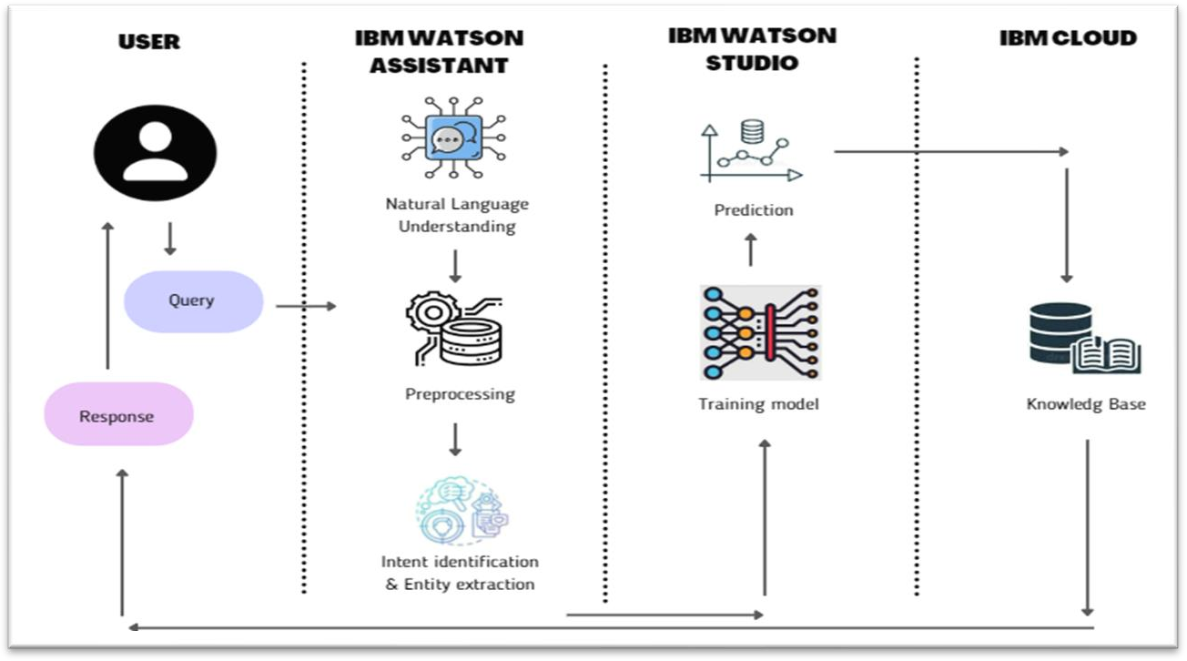

Components & Technologies:

|  |  |  |  |
| --- | --- | --- | --- |
| **S.No** | **Component** | **Description** | **Technology** |
| 1. | User Interface | Chatbot | HTML, CSS, JavaScript / Angular Js / React Js etc. |
| 2. | Application Logic-1 | Query processing | NLP and NLU |
| 3. | Application Logic-2 | Dealing with Dataset | IBM Watson STT service |
| 4. | Application Logic-3 | Training and Building Deep Learning Model | IBM Watson Studio |
| 5. | Application Logic-4 | Matching intent / Entities | IBM Watson Assistant ,IBM Watson Studio, Knowledge Base/Studio |
| 6. | Application Logic-5 | Deployment | Python Flask |
| 7. | Database | Data Type –Dialog, Intent etc. Configurations done using small integration Code snippets such as Javascript , SQL and can also be done using  Watson APIs. | MySQL or NoSQL or IBM DB2 |
| 8. | Cloud Database | Database Service on Cloud | IBM DB2, IBM Cloudant etc. |
| 9. | File Storage | We store dataset | IBM Block Storage or Other Storage  Service or Local Filesystem, IBM cloud, IBM Watson studio |
| 10. | External API-1 | To integrate powerful text analytics, linguistics, and dialogue into chatbot | IBM Watson Assistant API,v2 runtime API, etc. |

|  |  |  |  |
| --- | --- | --- | --- |
| 11. | External API-2 | Banking API –Data transfer between two systems and data accessibility. | Banking API, etc. |
| 12. | Machine Learning Model | Intent detection model and other deep learning models | Object Recognition Model, Intent  detection model, IBM Watson studio etc. |
| 13. | Infrastructure (Server / Cloud) | We'll install the chatbot using Flask in the web page on the cloud server. | Python Flask etc. |

Table-2: Application Characteristics:

|  |  |  |  |
| --- | --- | --- | --- |
| **S.No** | **Characteristics** | **Description** | **Technology** |
| 1. | Open-Source Frameworks | Open-source frameworks used is IBM Watson | Technology of Opensource framework- IBM Watson |
| 2. | Security Implementations | IBM Cloud | Watson assistant has certifications such as ISO,SOC2,US HIPAA,  European Union GDPR,PCI DSS. We use security systems such as TCS/SSL,IPSEC ,Third party CAs, HTTPS, Encrypted file systems, Encrypted storage systems, Key management systems, AES -256 bit. |
| 3. | Scalable Architecture | Chatbot architecture consist of four pillars. They are intents, entities ,data flow, scripts (3 – tier architecture –presentation tier, application tier, data tier and Micro-services architecture) | Technology used –IBM Watson Assistant |
| 4. | Availability | The Bot is made available using load balancers, distributed servers etc. | Technology used –IBM Watson Assistant |
| 5. | Performance | IBM Watson –automate processes, The deep learning model is trained using IBM Watson studio for better performance, Cache, CDN’s, etc. | Technology used –IBM Watson |